
PMO Enhancements
Portfolio Report
Ministry of Youth Affairs | Power Platform Solution
Short showcase version of the thesis project

Platform | Microsoft Power Apps, Power Automate, SharePoint Lists, Power BI
Focus | Project requests, approvals, KPIs, milestones, documents, reporting
Value | Centralized governance, traceability, automation, and real-time visibility
Output | A concise portfolio report for showcase or submission

1. Executive Summary
This project delivers a low-code PMO platform for the Ministry of Youth Affairs. It replaces spreadsheet-based tracking and manual follow-ups with a structured digital workflow built in Power Apps, Power Automate, SharePoint Lists, and Power BI.
The solution covers the full project lifecycle: request submission, multi-level approvals, project creation, milestone tracking, KPI entry, document handling, history logging, and executive reporting.
The portfolio version keeps the essentials only, so it is easier to review, present, and submit.
Project at a glance
Client | Ministry of Youth Affairs
Core problem | Scattered records, manual approvals, and limited traceability
Solution | Centralized PMO workflow and reporting platform
Main users | Requester, Manager, Chief, Director, PMO Admin
Key outcomes | Faster approvals, better visibility, reduced manual effort

2. Key Features
- Project request submission with staged approvals: Manager -> Chief -> Director.
- Automated notifications and controlled updates through Power Automate.
- KPI entry, aggregation, and dashboard reporting.
- Milestone tracking, extension requests, and project status monitoring.
- Document upload and retrieval linked to each project.
- Lookup management and role-based access for governance.

3. Workflow and Design Overview
The solution follows a clear workflow. A request is submitted in Power Apps, validated, and routed through the approval chain. Once approved, the system creates the project record, sends notifications, and opens the project for monitoring and reporting.
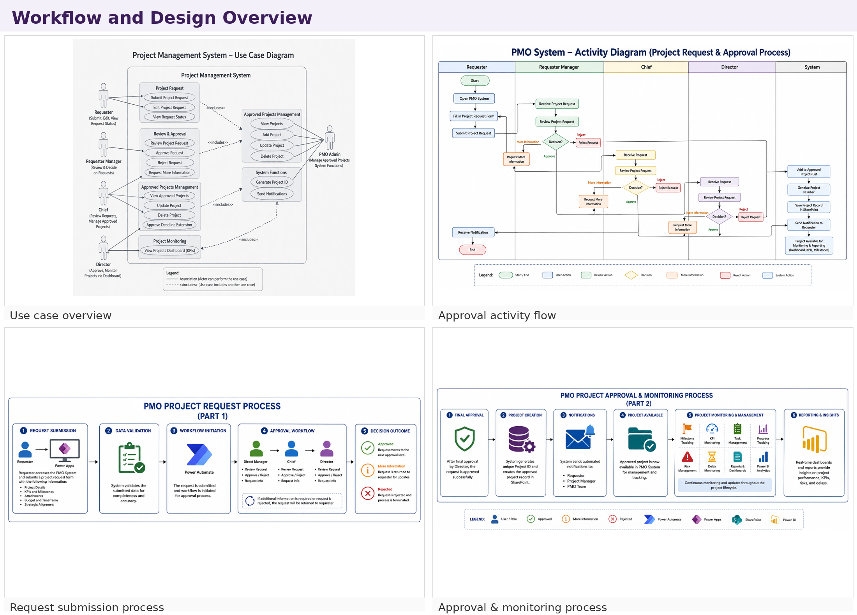
Figure 1. Workflow and design overview
The design combines a simple user interface with structured backend lists. This keeps the system maintainable while still supporting approvals, audit trails, and reporting.

4. Core Application Screens
These screenshots highlight the main user-facing pages. The dashboard gives a quick summary, the projects page lists active records, and the requests pages handle submission and approval activity.
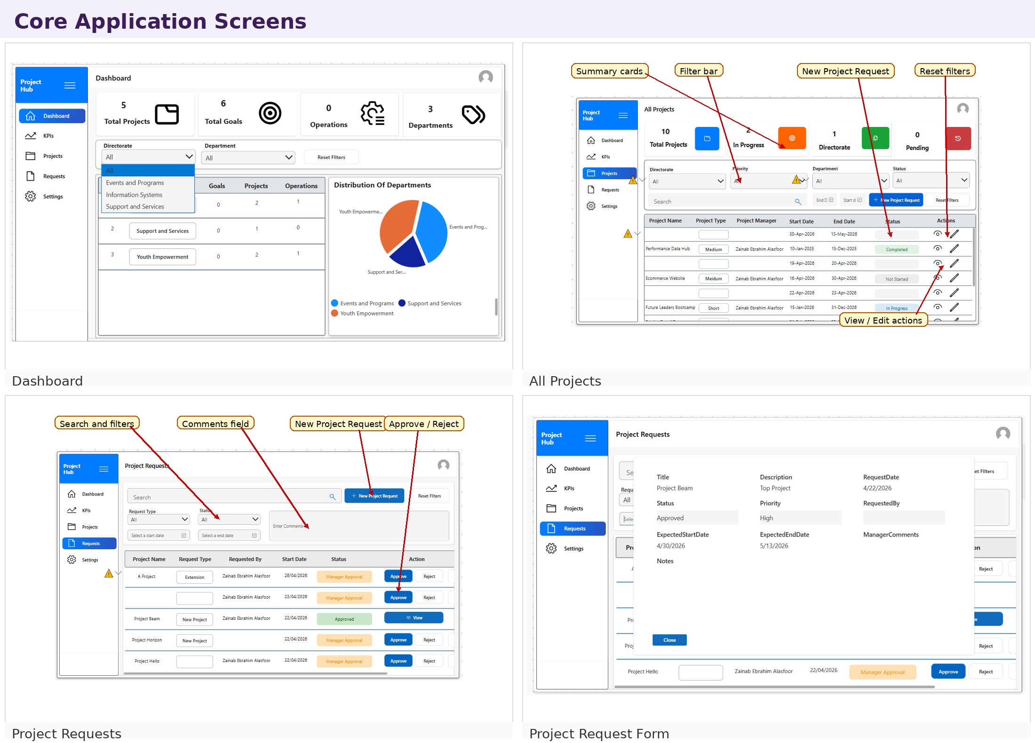
Figure 2. Main application screens
The interface is intentionally consistent across pages so users can move from overview to action without re-learning the layout.

5. Operational Screens
The operational views support day-to-day PMO work. KPI records can be created and edited, documents can be uploaded and searched, milestones can be updated, and lookup lists can be maintained centrally.
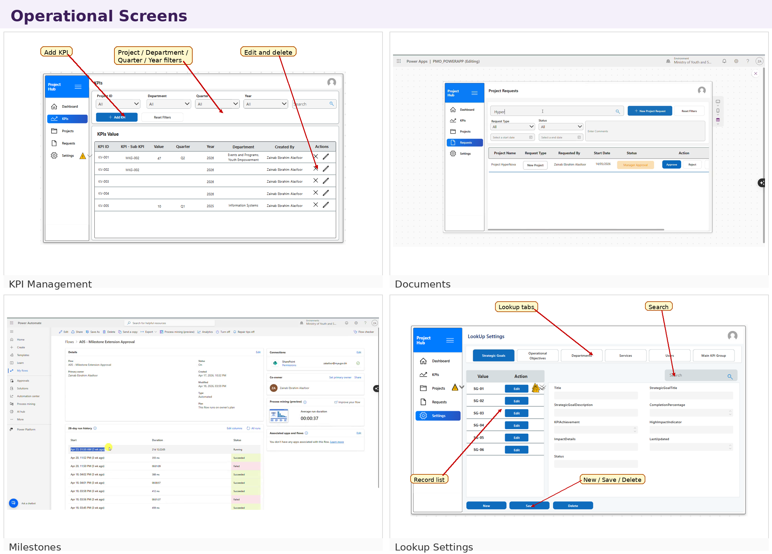
Figure 3. Operational management screens
This part of the system reduces duplication and helps keep the data model clean, controlled, and easy to extend.

6. Reporting and Delivery
The reporting layer provides visual summaries for executive review, while the platform also supports user-role management and delivery tracking. Power BI dashboards surface project progress, KPI performance, and risk status in a format suitable for management review.
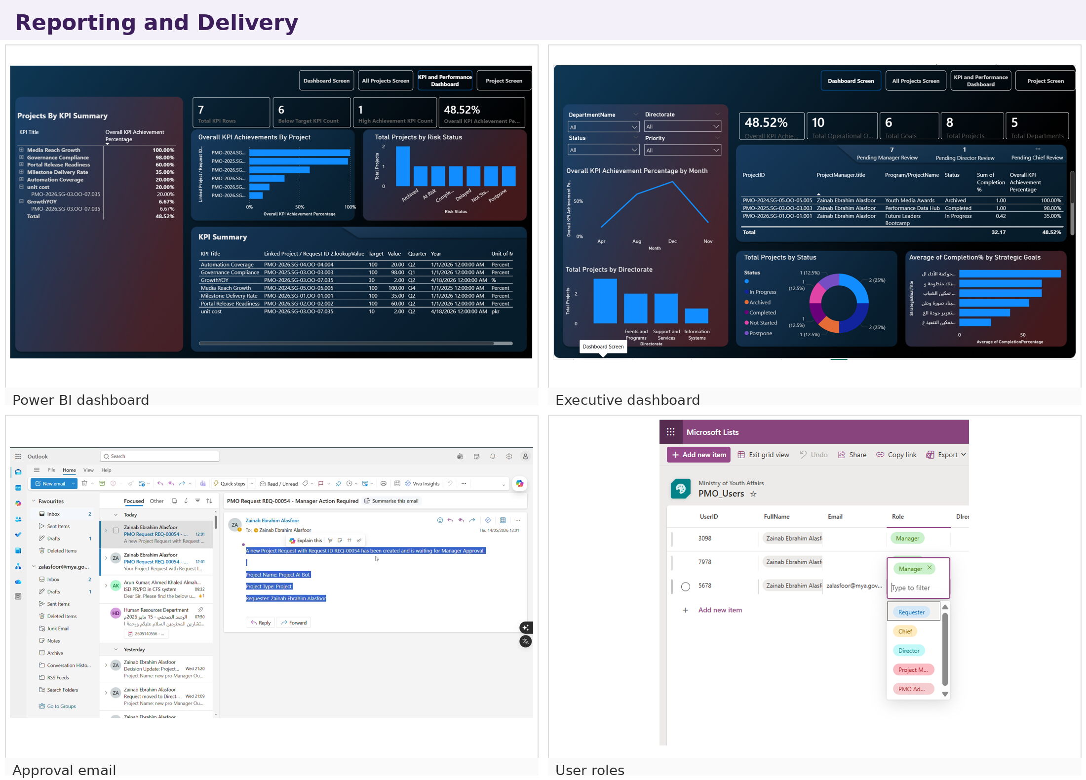
Figure 4. Reporting, analytics, and delivery views
Together, the delivery layer and dashboards help the PMO team monitor work in real time and respond faster to delays or approval bottlenecks.

7. Conclusion
The PMO Enhancements project demonstrates how a practical business workflow can be digitized with Microsoft Power Platform. The final system improves visibility, standardizes approvals, centralizes records, and gives the PMO a stronger foundation for governance and reporting.
For a portfolio submission, the short version focuses on the story of the solution rather than the full thesis detail: problem, build, workflow, screens, and outcomes.
- Centralized PMO operations in one platform.
- Reduced manual coordination and spreadsheet dependency.
- Improved traceability through history and approvals.
- Provided actionable dashboards for management visibility.

